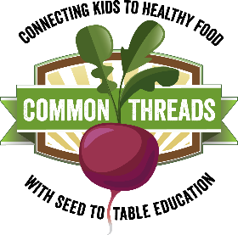
Harvest of the Month:
Kale

This month in adventurous eating: The almighty adventure bite.
When a student seems particularly hesitant to try a new food, challenge them to take an ‘adventure bite’. Being asked to eat an entire serving might seem daunting, but an ‘adventure bite’ sounds fun and much more achievable. Even if they have tasted the food before, it has probably been awhile since they’ve given it a try and taste buds change over time. Remind your class that it is okay if the Harvest of the Month item isn’t their favorite, but they won’t know until they try!

Nutrition Sound Bite: Kale is super green and super healthy! Usually veggies with more vibrant colors (especially those deep greens and oranges) are richer in vitamins and minerals. Make your plate as colorful as possible!

Nutrition Digest:
- One serving of kale is 2 cups when it is raw, but only ½ cup when it is cooked. Kale and other leafy greens cook down a lot, so don’t be shy and pile your greens high!
- Kale is a great source of vitamins A, C, and K. It is also rich in minerals such as calcium, which keep our bones and teeth strong. We need vitamin D to absorb calcium, so enjoy a glass of milk with your greens and you’ll be on your way to superhero strength!
- Compared to one cup of iceberg lettuce, one cup of kale has….
  - 30 times the amount of vitamin A!
  - 40 times the amount of vitamin C!
  - 32 time the amount of vitamin K!

Kale Trivia:
- T/F: Kale is a leafy, wild cabbage.
  - True! Can you describe how a kale plant looks different from typical green cabbage?
- T/F: Kale can grow in cold temperatures and even withstand frost.
  - True! That’s why we can find kale at the farmers’ market even in the cooler months.
- Cold temperatures make kale leaves __________.
  - a) more bitter b) softer c)crispier d) sweeter

