**Harvest of the Month feature**

**JUNE - SNAP PEAS**

**Try them in school lunch on** _______________

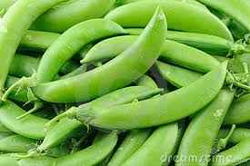

* Snap peas are an important part of a healthful diet because they are a good source of vitamin K, vitamin C, fiber and potassium. Snap peas are full of good vitamins and minerals that strengthen your immune system. They are best eaten alone and uncooked!

**Did you know?**

* Peas are part of the legume family
* 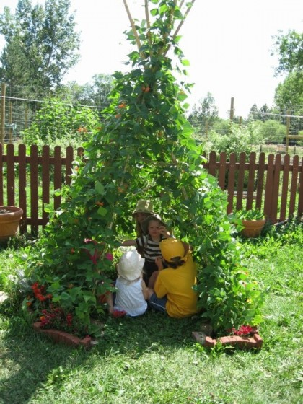The whole sugar snap pea can be eaten together (the outer pod and the inside pea).
* Even the tender “pea shoots” are edible and offer a delicious flavor to any salad.
* Only 5% of all peas grown are sold fresh; over half are canned and most of the rest are frozen.
* Peas are very easy to grow so they are an ideal first crop for children and beginning gardeners.
* Pea vines like to climb on something as they grow. Try making a pea teepee.

**Creating lifelong healthy eaters by connecting the cafeteria to the garden, classroom, and the community.**

***~GIVE IT A TRY AT HOME~***

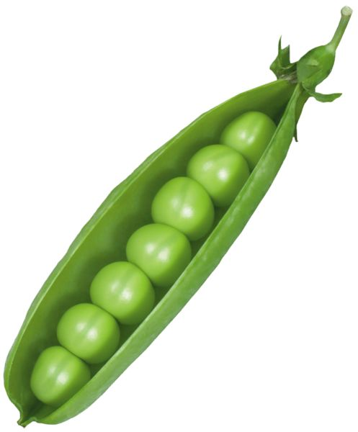

**Sugar Snap Peas with Yogurt Dip**

Preparation time: 10 min.

## c18e9a959317e2f3f0cdcc9d25a745329dbed16cc2db8984f6b6e882e1f504fbIngredients:

Fresh sugar snap peas

1 cup yogurt

1 garlic clove, minced

1 tablespoon fresh dill, chopped

1 teaspoon lemon juice

Salt and pepper to taste

**What to do:**

* Combine yogurt and following ingredients in a bowl.
* Dip sugar snap peas and enjoy!



**Local food is fresher!**

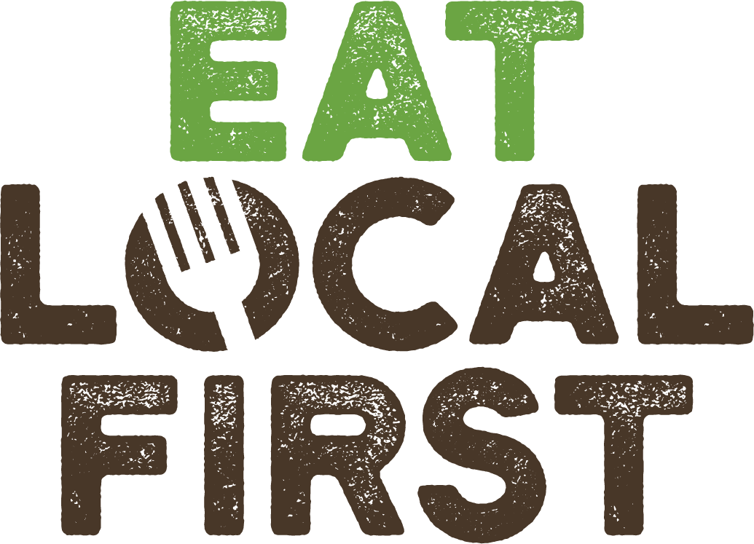At first blush, it seems pretty easy to tell whether something is fresh just by looking at it. In reality, though, produce can be weeks or even months old and still look fresh. By buying locally, you can be sure that your produce was harvested fresh and still retains its flavor and nutrition, plus it supports our local farms and community. Talk about a win-win!