Harvest of the Month
MAY - RADISHES
Try them in school lunch on_______________

Reasons to Eat Radishes
- Radishes are a member of the Brassicaceae family along with other vegetables like kale, collards, mustards, broccoli, cabbage, horseradish, and cauliflower.
- When people think of radishes, they usually think of the bright red and white roots. You can also eat radish greens and seeds!
- Radishes are an excellent source of vitamin C, phosphorus, potassium, zinc, and fiber. They can improve your health by regulating your body’s blood pressure, preventing respiratory problems, and easing digestion.

Did you know…
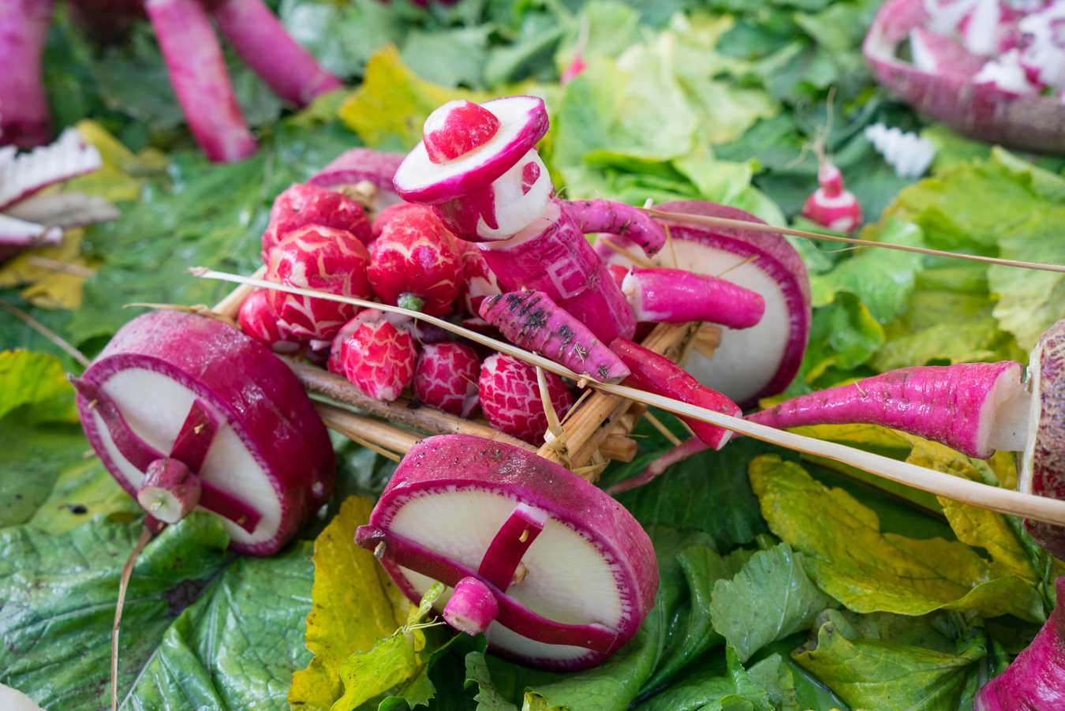
- In Oaxaca, Mexico, December 23 is known as “Night of the Radishes.” People celebrate the festival by carving all kinds of scenes out of radishes!
- Radishes, onions, and garlic were used as “wages” to pay the Ancient Egyptian laborers who built the pyramids.
- Washington is one of the largest producers of radish and other vegetable seeds in the world. 70% of radish, carrot, spinach, and beet seeds come from Washington!
Creating lifelong healthy eaters by connecting the cafeteria to the garden, classroom, and the community

~GIVE IT A TRY AT HOME~
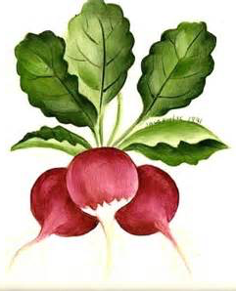
Radish Salsa
Prep Time: 30 minutes; Makes: About 2 cups
Recipe From: Mark Bittman
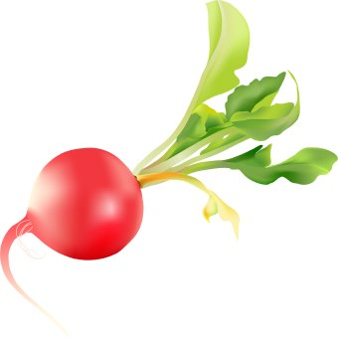
Ingredients:
1 pound radishes
½ English cucumber
1 scallion
1 clove garlic
1 tablespoon minced fresh chili (like jalapeno or serrano), to taste
2 tablespoons lemon juice
¼ cup chopped fresh cilantro leaves
Salt and pepper
What to do:
- Wash and chop radishes, cucumber, scallion, chili, and cilantro.
- Add to bowl with garlic and lemon juice. Season with salt and pepper. Mix thoroughly. Taste and add more chili, lemon, or salt as needed. Enjoy!
Strong Local Food System = A Strong Community
Spring is here and local food is sprouting up throughout our county’s pastoral landscape. Farmers markets are opening up for the season, and you can find more local food on grocery store shelves, restaurant menus, and through Community Supported Agriculture (CSA) shares. Enjoy a radish, spring greens, or fresh chives this month, among other things, and celebrate the bounty of our place in the world!

