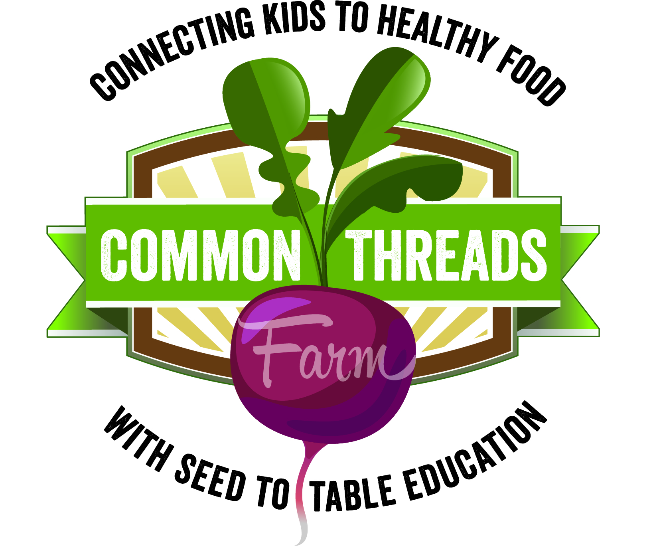

Harvest of the Month:
Cabbage

This month in adventurous eating: Don’t yuck my yum!
When trying new foods in your classroom, remind students about good eating etiquette. If a student tries a bite and then exclaims things like “gross!” “bleh!” or “disgusting!” they are yucking everyone else’s yum. Instead, invite them to use the phrase “It’s not my favorite.” This is a polite way that students can still express their opinion. After all, we all have different taste buds, and that’s okay!

Nutrition Sound Bite: Cooked, raw, purple, or green, there are lots of ways to eat cabbage! Any which way you eat it, cabbage packs a nutritional punch and a tasty crunch.

Nutrition Digest:
- One serving of shredded cabbage is ½ cup, or about one cupped handful.
- A single serving of green cabbage contains only 9 calories. Can you guess why? (It’s mostly made up of water!)
- Cabbage is a stellar source of vitamins A and K. Vitamin K is essential for blood clotting. Without it, we wouldn’t be able to form scabs and a simple papercut could turn into a serious injury!

Cabbage Trivia:
- T/F: Cabbage is one of the oldest vegetables in existence.
  - True! It has been a dietary staple around the world for thousands of years.
- In what year was cabbage first introduced in North America?
  - In 1541 French explorer Jacques Cartier introduced cabbage to North America.
- What percent of cabbage seed is grown in Washington State?
  - Washington state provides 75% of the US production and 25% of the world production of cabbage seed.
- T/F: Cabbage is related to lettuce.
  - False! Cabbage is related to broccoli, cauliflower, and Brussels sprouts.
- Cabbage is easy to grow in Whatcom County because our weather here is __________.
  - a) Cool b) Wet c) Hot d) Fun

