**The December Harvest of the Month feature is... CABBAGE**

Try it in school lunch on _________________

**All the different types!**

* **Green Cabbage-** sweet by nature and super versatile! Can be eaten raw in salads, and slaws or cooked in a stir-fry.
* **Red Cabbage-** The sister of the green cabbage. Heads tend to be a bit smaller than green cabbage. Thinly slice it to add a beautiful color to salads.
* **Napa cabbage-** Sometimes called “Chinese cabbage,” Napa is different from the traditional heads of cabbage. It has long, light green leaves with a mild flavor and peppery kick.
* **Savoy Cabbage-** Also known as curly cabbage from the ruffled leaves. Leaves are very tender and work nicely as a fresh and crunchy wrap. Try using them in place of rice paper or tortillas.
* **Bok Choy:** Most often used in stir-fries, Bok Choy has green leaves with pale green stalks and offers a mild flavor.
* **Brussels Sprouts-** The tiny cabbage! Roasting Brussels sprouts brings out the great flavor of this little cabbage.

**Support Our Community with your Food Dollars!**

Whatcom County family farms are part of our community, as are the businesses that purchase from local farms. When we buy local food we are supporting farmers, fishers, farm workers, truck drivers, equipment makers, grocery store clerks, cooks, bakers, compost makers and more.

***~ GIVE IT A TRY AT HOME ~***

MC900331270[1]MC900331270[1]MC900331270[1]MC900331270[1]MC900331270[1]MC900331270[1]MC900331270[1]MC900331270[1]MC900331270[1]MC900331270[1]MC900331270[1]

**Cabbage Crunch Salad**

Preparation time: 20 min. Serves 3-5

Recipe Inspired by Cook It Allergy Free

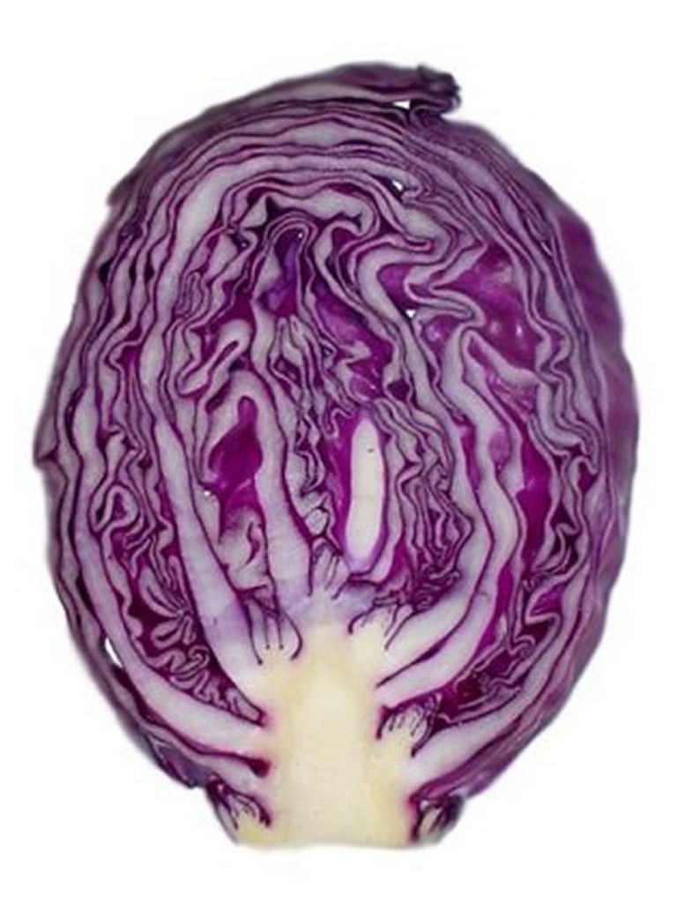**Ingredients:**

Half a medium head of red cabbage

¼ cup finely chopped apple

¼ cup dried cranberries

¼ cup sunflower seeds

Dressing:

¼ cup apple cider vinegar

¼ cup olive oil

3 Tbs. sour cream

3 Tbs. maple syrup

Salt and pepper to taste

**What to do:**

* Combine cabbage, apples, and cranberries in a salad bowl.
* In a blender, mix together all dressing ingredients.
* Pour dressing over cabbage salad mixture. Let sit for an hour or up to overnight. The flavors will fuse together and taste better with time. Enjoy!

MC900331270[1]MC900331270[1]MC900331270[1]MC900331270[1]MC900331270[1]MC900331270[1]MC900331270[1]MC900331270[1]MC900331270[1]MC900331270[1]MC900331270[1]

**Creating lifelong healthy eaters by connecting the cafeteria to the garden, classroom, and the community.**