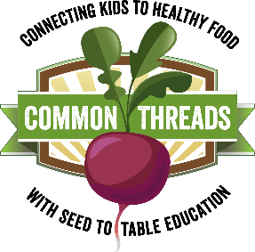
Harvest of the Month:
Summer Squash

This month in adventurous eating: Variety is the spice of life!
Remind students that they may think they don’t like a food from having tried it before, but it’s possible that they would like it if it were prepared differently. One great thing about squash, and many other foods, is that there are so many ways to prepare them. For example, versatile squash can be cooked in sweet or savory dishes, baked into breads, or just served plain, raw or cooked. Keep trying it and find the most delicious ways you enjoy squash.

Nutrition Sound Bite: Squash really does squash the competition when it comes to eating well! It is full of a variety of important nutrients and comes in lots of shapes, sizes, flavors, and textures. Squash is quite the crowd pleaser!

Nutrition Digest:
- One serving of summer squash is ½ cup cooked.
- Summer squash is loaded with vitamins and minerals including Vitamins A, B₆, C, & K, as well as Folate, Magnesium, and Potassium. Along with plenty of dietary fiber and protein, summer squash has something good for every body!
- Some squash varieties also provide thiamin, which helps the body change carbohydrates into energy.

Squash Trivia:
- T/F: You must peel summer squash and remove the seeds before eating.
False! Unlike winter squash, summer squash are harvested when they are immature and the squash is tender and edible so you don’t have to peel them, and can eat the seeds and all.
- The name squash is derived from the Native American word askutasquash, which means
  - a) “food eaten raw” b) “hungry people c) “colorful gourds” d) “delicious”
- The entire squash plant, such as the leaves, tendrils, shoots, stems, flowers, seeds, and fruit, can be eaten.
True! The entire plant can be eaten.
- Is squash a fruit or a vegetable?
Even though squash are typically cooked and eaten as a vegetable, technically, squash are a fruit because they contain the plant’s seeds.

