**Harvest of the Month**

**JANUARY – APPLES**

**Try it in school lunch on__________________**

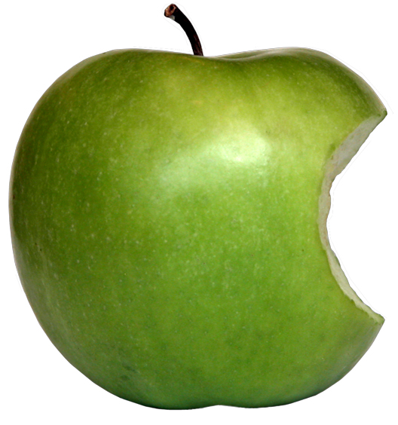***An Apple a day…***

***…Keeps the doctor away.***

That’s what you always hear…but it’s true! Apples are sweet, delicious, and a good choice for a nutrient-dense fruit. Apples contain antioxidants and phytonutrients that can help regulate blood sugar, play a role in the digestive tract, and boost the immune system with Vitamin C.

**Did you know…**

Washington state grows about half of all apples eaten fresh in the United States?

**What to do with all those apples?**

Apples are a wonderfully versatile fruit. They can be eaten raw or cooked, in desserts or in salads, in baked goods, made into sauce, or sliced and dipped in peanut butter, honey or yogurt.

And don’t forget to bring one to school for your teacher!

**Eating Local All Year Round**

As you think about your goals and intentions for the new year, consider eating more local food in the new year. A resolution to buy from local farmers (and local food businesses) is a resolution to invest in a better future for you, our community, and generations to come. Bonus: it’s fresher and tastes better too!

**Creating lifelong healthy eaters by connecting the cafeteria to the garden, classroom and the community**

***~ GIVE IT A TRY AT HOME ~***



**Apple Cinnamon Muffins**

Preparation Time: 20 min; Cooking Time: 25min

**Ingredients:**

1 ½ cups all-purpose flour

¾ cup white sugar

½ teaspoon salt

2 teaspoons baking powder

1 teaspoon ground cinnamon

1/3 cup vegetable oil

1 egg, beaten

1/3 cup milk

2 apples – peeled, cored and chopped

For Topping:

½ cup white sugar

1/3 cup all-purpose flour

½ cup butter, cubed

1 ½ teaspoons cinnamon

**What to do:**

* Preheat oven to 400 degrees F. Grease six muffin cups or line with paper muffin liners.
* Stir together 1 1/2 cup flour, 3/4 cup sugar, salt, baking powder and 1 teaspoon cinnamon. Mix in oil, egg and milk. Fold in apples. Spoon batter into prepared muffin cups, filling to the top of the cup.
* In a small bowl, stir together 1/2 cup sugar, 1/3 cup flour, butter and 1 1/2 teaspoons cinnamon. Mix together with fork and sprinkle over unbaked muffins.
* Bake in preheated oven for 20 to 25 minutes, until a toothpick inserted into center of a muffin comes out clean.

