The March Harvest of the Month feature is...
RADISHES
Try them in school lunch on _______________

Radish Family Tree
Radishes are a member of the Brassicaceae family along with other vegetables like kale, collards, mustards, broccoli, cabbage, horseradish, and cauliflower. All of these different vegetables have the same parent, a single variety of wild mustard! Color the family tree showing radishes and its cousins!
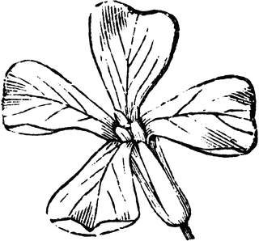
Wild Mustard

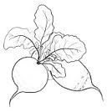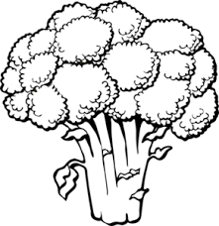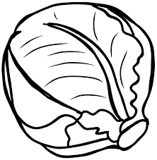
Radishes Broccoli Cabbage

Reasons to Eat Radishes
When people think of radishes, they usually think of the bright red and white roots. You can also eat the radish greens and seeds! Radishes are an excellent source of vitamin C, phosphorus, potassium, zinc, and fiber. They can improve your health by regulating your body’s blood pressure, preventing respiratory problems, and easing digestion!

Creating lifelong healthy eaters by connecting the cafeteria to the garden, classroom, and the community
~GIVE IT A TRY AT HOME~
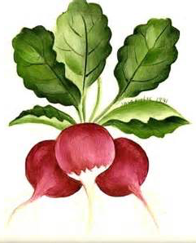
Radish Salsa
Prep Time: 30 minutes; Makes: About 2 cups
Recipe From: Mark Bittman

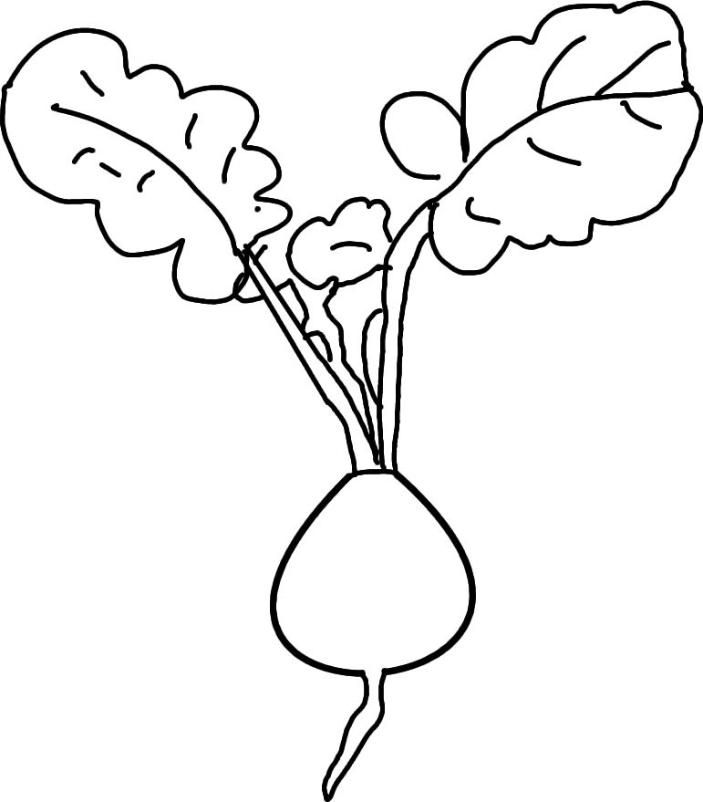
Ingredients:
1 pound radishes
½ English cucumber
1 scallion
1 clove garlic
1 tablespoon minced fresh chili (like jalapeno or serrano), to taste
2 tablespoons lemon juice
¼ cup chopped fresh cilantro leaves
Salt and pepper

What to do:
- Wash and chop radishes, cucumber, scallion, chili, and cilantro.
- Add to bowl with garlic and lemon juice. Season with salt and pepper.Mix thoroughly. Taste and add more chili, lemon, or salt as needed. Enjoy!

Did you know?
- In Oaxaca, Mexico, December 23 is known as “Night of the Radishes.” People celebrate the festival by carving all kinds of scenes out of radishes!
- Radishes, onions, and garlic were used as “wages” to pay the Ancient Egyptian laborers who built the pyramids.
- Washington is one of the largest producers of radish and other vegetable seeds in the world. 70% of radish, carrot, spinach, and beet seeds come from Washington!

