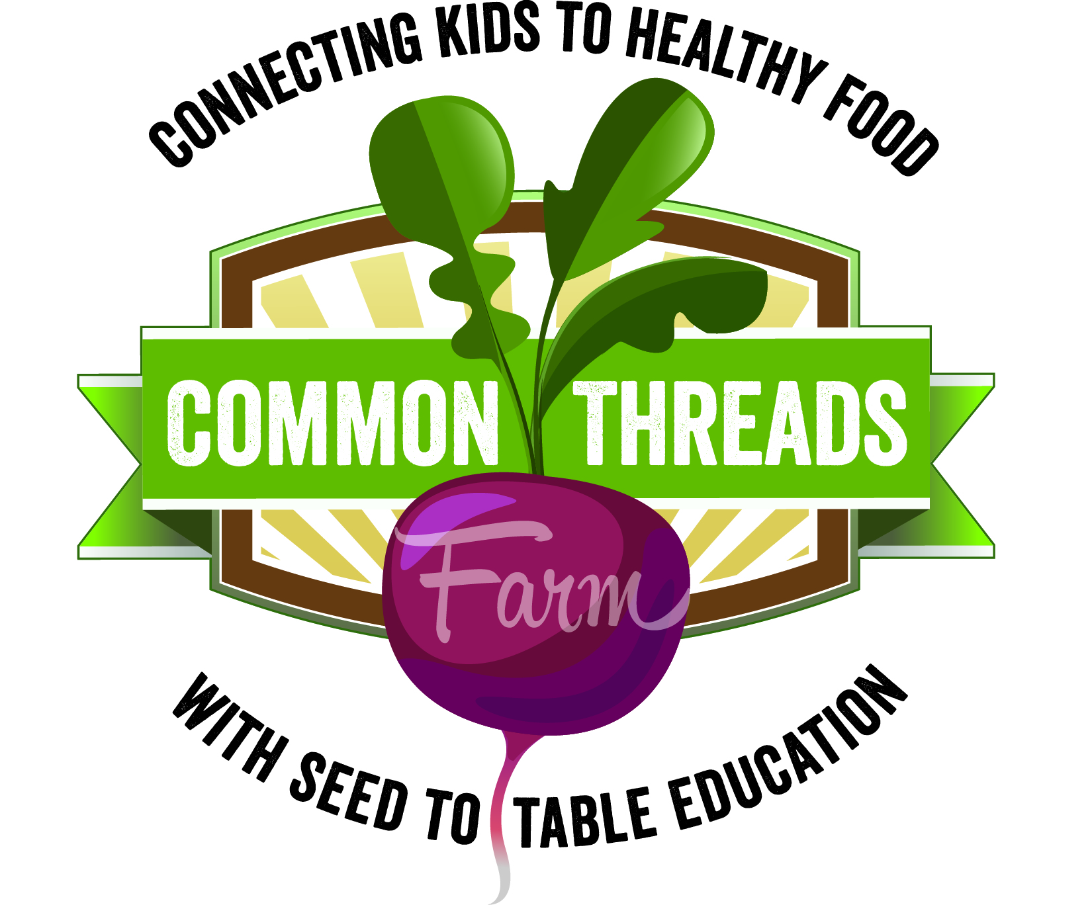

Harvest of the Month:
Radishes

This month in adventurous eating: Take a trip to your school garden!
Tying in your Harvest of the Month snack with a trip to your school garden is a spectacular way to help students make the connection between what they eat and how it’s grown. Talk about whether the Harvest of the Month snack is in season and if it is grown locally (Is it growing in the garden right now? Have you seen it at the farmers’ market?). All of the Harvest of the Month items are Whatcom-grown, and several of the snacks are crops that can be planted in school gardens. Lots of research shows that when kids are involved in growing healthy food, they are more likely to eat it. The National Gardening Association maintains an updated list of research on the benefits of kids growing food.

Nutrition Sound Bite: Radishes are at the root of healthy eating! They provide numerous essential nutrients, not to mention a delightful crunch and a spicy kick!

Nutrition Digest:
- One serving of radishes is ½ cup, or about one cupped handful.
- Radishes are a good source of fiber and potassium. Potassium helps maintain normal function of the heart, kidneys, muscles, and nervous system. It also helps maintain fluid balance within the body.
- Radishes are also really great at providing the body with electrolytes, which are essential for all kinds of physical activity. Radishes keep your engine revving!

Radish Trivia:
- About how many pounds of radishes do Americans eat each year?
  - 400 million pounds!
- T/F: A radish is the root of a plant in the mustard family.
  - True! Can you think of how radishes and some mustards have similar tastes?
- In which country is Christmas Eve also known as “The Night of the Radishes”?
  - Mexico. In the city of Oaxaca, “Noche de Rabanos” festivities feature all sorts of creative carvings, from animals to nativity scenes, all made out of radishes!
- T/F: The temperature in which a radish grows can affect how spicy it tastes.
  - True! If it’s a long, hot summer, the radishes in your garden will taste hotter. Similarly, when the summer is milder, your radishes will taste milder too!

